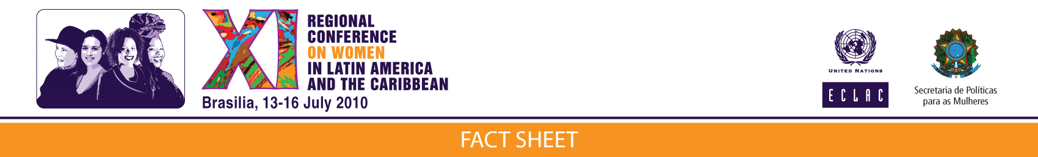
ECLAC document “What kind of State? What kind of equality?”:

WOMEN’S UNPAID WORK
IS AN OBSTACLE TO THEIR ACHIEVING FULL EQUALITY

The full exercise of women’s rights is contingent on their first attaining, among other things, economic autonomy, that is, the capacity to generate and manage their own resources. This, in turn, depends on their being able to access the labour market on the same terms and conditions as men.
However, unless and until women are relieved of the burden of unpaid work in the home and of care for children, older persons, the sick and disabled, which usually falls on their shoulders, equality for women in the work sphere will continue to be elusive.
Achieving equality in the workplace calls for a new equation between the State, the market and the family in order to redistribute the total (paid and unpaid) work burden. This means that policies, practices, services and public and private standards must be put in place to relieve women of their care burden and enable them to access the labour market; at the same time, incentives, programmes and a cultural shift must be orchestrated so that men can share household responsibilities and care work.
Unpaid domestic work and caregiving by women may be interpreted as a transfer or subsidy from the domestic sphere to the State or private sector, which are thus spared the cost of these services. Conversely, part of the worker’s wage may be transferred to unpaid work in the home to finance the inputs that these chores imply.
The female labour force participation rate in urban areas rose from 42% in 1990 to 52% in 2008, in line with a steady improvement in the level of education

attained by women. The higher women’s level of schooling, the higher their participation rate.
Latin America and the Caribbean (selected countries):
Total hours worked, time spent on domestic work and time spent on paid work, by sex
(a) Hours per day

However, this higher education has not been rewarded with more income or better quality jobs, and the wage gap with men persists (79% of income
for the same work), although this figure has declined by 10 percentage points since 1990.
One of the features of the labour market is segmentation: the concentration of women in occupations considered to be women’s work, for example in health, education, services (including domestic and financial) and commerce. Another characteristic is that the unemployment rate remains higher among women than among men.
Although the percentage of women who do not have incomes of their own declined by 11 percentage points between 1994 and 2008, 31.6% of women still have not attained economic autonomy. In the case of men, the figure is only 10.4%.
Latin America (simple average of 17 countries, urban areas): population aged 15 years and over without incomes of their own, by sex, 1994-2008ª
(Percentages of the total for each sex)

Source: Economic Commission for Latin America and the Caribbean (ECLAC), on the basis of special tabulations of data from household surveys conducted in the respective countries.
ªData from the following countries are included: Argentina, Brazil, Chile, Colombia, Costa Rica, Ecuador, El Salvador, Honduras, Mexico, Nicaragua, Panama, Paraguay, Plurinational State of Bolivia and Uruguay (1994); Argentina, Brazil, Chile, Colombia, Costa Rica, Ecuador, El Salvador, ,Honduras, Mexico, Panama, Paraguay, Plurinational State of Bolivia and Uruguay (1999); Argentina, Brazil, Chile, Colombia, Costa Rica, Dominican Republic, Ecuador, El Salvador, Guatemala, Honduras, Mexico, Panama, Paraguay, Peru, Plurinational State of Bolivia and Uruguay (2002); Argentina, Brazil, Chile, Colombia, Costa Rica, Dominican Republic, Ecuador, El Salvador, Guatemala, Honduras, Mexico, Panama, Paraguay, Peru, Plurinational State of Bolivia and Uruguay (2005); and Argentina, Brazil, Chile, Costa Rica, Dominican Republic, Ecuador, Guatemala, Honduras, Mexico, Panama, Paraguay, Peru, Plurinational State of Bolivia and Uruguay (2008).
Women’s entry into the labour market has resulted in an additional burden in terms of work time, since the time and energy devoted to their work in the home tend to remain the same.
Time-use surveys carried out in 12 Latin American countries since 1998 reveal that women invariably devote more time than men to unpaid household work and that their total work burden is much greater than men’s.
There is no network of public services to take care of some of these tasks and only women with higher incomes can afford to hire services or people —generally other women– to perform out, thus freeing themselves of responsibilities and finding more time to devote to paid work.
The situation of poor and middle-class women is different, since the lack or insufficiency of public services means that it is virtually impossible for them to reconcile work and family life, and means they lose out on job opportunities.

