

Chapters III and IV of “Time for Equality. Closing Gaps, Opening Trails”
PRODUCTIVE AND TERRITORIAL CONVERGENCE
FOR A MORE EQUAL SOCIETY

The deep social inequalities in Latin America are largely explained by the enormous structural heterogeneity of its economies; that is, by internal gaps (productivity differences among sectors, within sectors and among companies in a country) and external gaps (their technological capacities compared to developed nations).
Productivity gaps reflect and at the same time reinforce differences in capacities, incorporating technical progress, bargaining power, access to social safety nets and options for upward occupational mobility, with consequences on wages and income distribution.

The internal gap is also reflected in the performance of different types of agents (microenterprises, SMEs and large enterprises). The relative productivity differences within a country (between large enterprises and others) are much greater in Latin America than in developed countries. For example, whereas the productivity of a microenterprise in Chile is 3% that of a large company, the equivalent in France is 71%. A similar trend can be observed in the differences between microenterprises and SMEs.

Productivity gaps between Latin America and developed countries have deepened in recent years due to two main causes: the heterogeneity among sectors and enterprises which concentrates higher productivity in a few sectors and companies, and the specialization in natural-resource intensive branches of production with little capacity to spread technical progress to the rest of the production structure.

Reducing heterogeneity between sectors and agents should lead to better income distribution and less social exclusion. Diminishing the external productivity gap would increase competitiveness and lower per capita income differences with developed countries.

The State can play an active role in transforming the productive structure in order to approach the international productive frontier and have a more dynamic structure that can serve as an engine for growth and learning, as well as close internal productivity gaps that reproduce inequalities through structural heterogeneity.
This requires public industrial development policies, technological innovation, financing and fomenting SMEs.



Closing productivity gaps in countries in the region – both with regard to developed nations and within each economy – implies also reducing territorial socio-economic inequalities within each country.
Population and economic activity in Latin America is highly concentrated in different territories within countries, with the subsequent inequality in the territorial distribution of wealth. For example, per capita GDP in the wealthiest region of Brazil is eight times higher than per capita GDP in the poorest region.
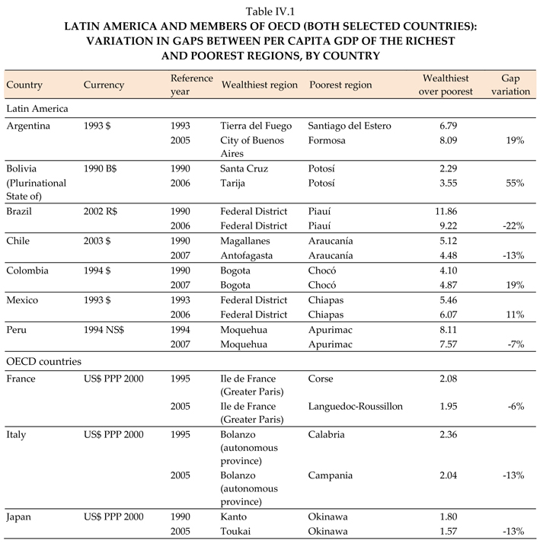
Source: ECLAC, based on official country data.

Over 75% of the population Latin America and the Caribbean is concentrated in urban areas, which are notoriously segregated along socio-economic lines. There is a high concentration of the poorer population and deprivations in the periphery, where poverty-reproduction factors are reinforced: low schooling, overcrowding, high unemployment and teenage pregnancies.

This urban layout intensifies segregation, as the concentration of informal economic activity and poverty tend to push down the price of land in those areas. The low value of land, in turn, limits municipal revenues from property taxes, business licenses and permits, restricting the State’s capacity to fund investment projects and build and maintain public services and infrastructure.

The contrast between different areas or territories within a country in terms of income, poverty, productivity and access to public services and infrastructure reflects and feeds on the inequalities at a national level.
It is essential, then, that poverty-reduction policies not only aim at productive convergence, but also territorial convergence, and the State has several potential instruments to do so.
One is the creation of territorial cohesion funds to transfer funds from the central level to subnational territories, committing them to be used in generating synergies among production, capacity-building and efforts to resolve basic deprivations.

Another instrument are intergovernmental transfers, with regional development policies administered at a national level and managed locally or at a provincial level. These policies can be financed largely through greater local tax collection in those areas.

To tackle urban segregation, the State can turn to area-specific allocations, compensatory resources and special programmes in disadvantaged areas, in addition to redistributing territorial taxes.

